What is the Area of Irregular Shapes?
As mentioned above, irregular shapes are those shapes that do not have equal sides or equal angles. The area of an irregular shape is the entire region covered by that shape on a two-dimensional plane. To find the area of an irregular shape, it can be divided into multiple familiar shapes, such as triangles, squares, and rectangles. Then, we can get the total area by adding the area of those smaller shapes. Also, the area of irregular shapes can be expressed in different units such as cm², ft², m², etc.
How to Find the Area of Irregular Shapes?
Finding the area of irregular shapes is not as easy as it is for regular shapes or polygons. However, there are different methods to estimate the area of any irregular shape. Here, you will learn two important methods of finding the area of given irregular shapes. They are:
- Dividing the shape into possible regular polygons
- Using the graph paper

Calculating the Area using Decomposition of an Irregular Shape
- Consider an irregular shape as given below:
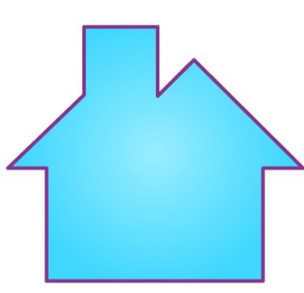
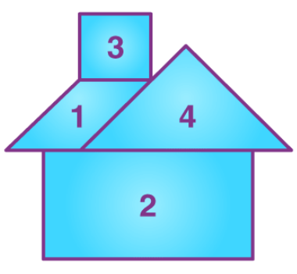
Therefore, the decomposed shape contains a parallelogram, rectangle, square and triangle. So, the area of the above irregular shape can be calculated as:
Area of the shape = Area of parallelogram + Area of rectangle + Area of square + Area of triangle
Area of Irregular Shapes Using Graph Paper
Let’s learn how to find the area of irregular shapes using graph paper with the help of an example.
If the shape is given on graph paper, we can directly count the number of squares covered by that shape. Otherwise, we need to draw the graph lines or square grids over the given irregular shape.
Go through the example given below to understand this method of finding the area of an irregular shape in a better way.
Example of Area of Irregular Shapes by Counting Squares
Question:
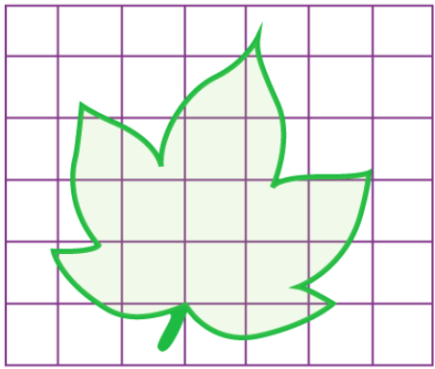
Find the area of the shape in square units.

Solution:
Let us count the squares that are completely covered, half covered and so on. Also, these can be marked as shown below:
Now, we need to write the number of squares that are covered by the shape.
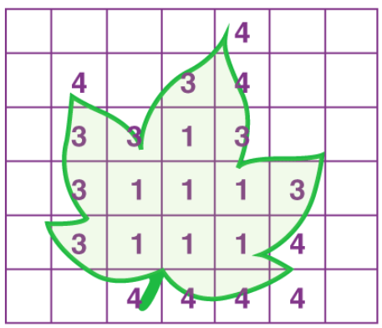
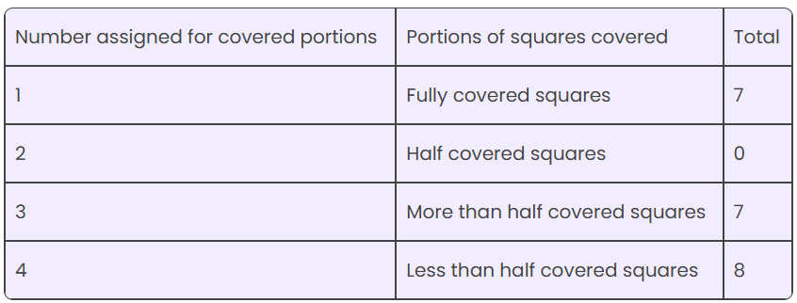

For fully covered square grids, we can take 1 square unit for each.
For half-covered squares, we should assign ½ square units for each.
If the square is covered more than half the portion, then assign 1 square unit for each such portion.
If the square grid is covered less than half, then assign 0 square units for each such portion.
Therefore, the area of the given shape = 7(1) + 0(½) + 7(1) + 8(0)
= 7 + 0 + 7 + 0
= 14
Hence, the area of the given irregular shape is 14 square units.
Similarly, we can find the area of irregular shapes given on graph paper. We can also draw the square grids, if it is not given on the graph paper.

Area of regular objects
